AI-ASSISTED CODING
ASSIGNMENT-2.3
---------------------------------------
NAME: Adepu Goutham Sri Bhargav
HALL-TICKET: 2403A510C4
BATCH NO: 05

Task 1:
● Description:
Use Google Gemini in Colab to write a function that reads a CSV file and calculates
mean, min, max.
Prompt:
Write a function that reads a CSV file and calculates mean, min, max.
CODE SCREENSHOT:
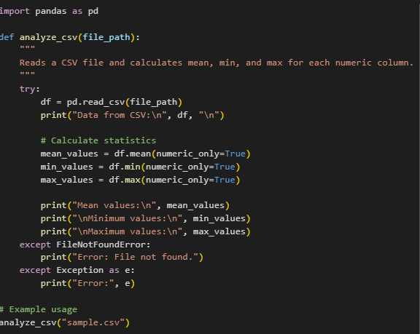
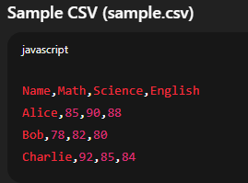

OUTPUT:
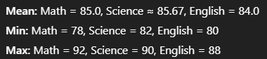

EXPLANATION:
The function reads a CSV file using the pandas library.
It calculates mean, minimum, and maximum for each numeric column.
It displays the original CSV data and the results.

--------------------------------------------------------------------------------------------------------------
Task 2:
● Compare Gemini and Copilot outputs for a palindrome check function.
Prompt: Give a python function to check whether the given function is palindrome or not.
CODE SCREENSHOT:
BY GEMINI:
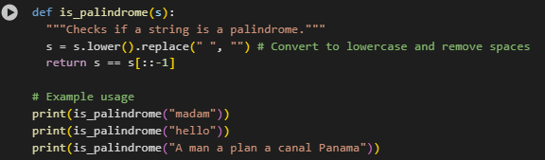
Output:
True
False
True
BY COPILOT:
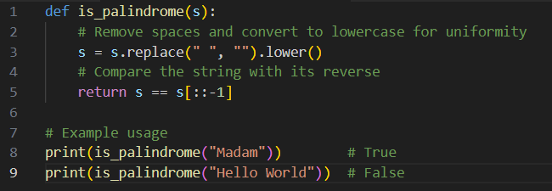
Output:
True
False
COMPARISION:
Aspect | Gemini | Copilot
Function Name | is_palindrome(s) | is_palindrome(s)
Docstring / Comments | Has a short docstring: """Checks if a string is a palindrome.""" | No docstring, but has inline comments explaining steps
Preprocessing Order | Converts to lowercase first, then removes spaces | Removes spaces first, then converts to lowercase
Method Used | s.lower().replace(" ", "") | s.replace(" ", "").lower()
Comparison Logic | return s == s[::-1] | return s == s[::-1]
Examples Given | - "madam" → True - "hello" → False - "A man a plan a canal Panama" → True | - "Madam" → True - "Hello World" → False
Number of Examples | 3 examples | 2 examples
Handling Case & Spaces | Yes (by converting to lowercase and removing spaces) | Yes (by converting to lowercase and removing spaces)
Clarity | More compact, fewer comments | More descriptive comments, better for beginners

----------------------------------------------------------------------------------------------------------
Task 3:
● Ask Gemini to explain a Python function (to calculate area of various shapes) line by
line.
PROMPT:
Generate a Python program that calculates the area of various shapes .
CODE:
import math
def calculate_square_area(side):
"""Calculates the area of a square."""
return side * side
def calculate_rectangle_area(length, width):
"""Calculates the area of a rectangle."""
return length * width
def calculate_circle_area(radius):
"""Calculates the area of a circle."""
return math.pi * radius**2
def calculate_triangle_area(base, height):
"""Calculates the area of a triangle."""
return 0.5 * base * height
print("Welcome to the Area Calculator!")
print("Please choose a shape from the options below:")
print("1. Square")
print("2. Rectangle")
print("3. Circle")
print("4. Triangle")
shape_choice = input("Enter the number corresponding to your chosen shape: ")
dimensions = {}
calculated_area = None
if shape_choice == '1':
try:
side = float(input("Enter the side length of the square: "))
if side >= 0:
dimensions['side'] = side
calculated_area = calculate_square_area(dimensions['side'])
print(f"The area of the square is: {calculated_area}")
else:
print("Error: Side length cannot be negative.")
except ValueError:
print("Error: Invalid input. Please enter a numeric value for the side length.")
elif shape_choice == '2':
try:
length = float(input("Enter the length of the rectangle: "))
width = float(input("Enter the width of the rectangle: "))
if length >= 0 and width >= 0:
dimensions['length'] = length
dimensions['width'] = width
calculated_area = calculate_rectangle_area(dimensions['length'], dimensions['width'])
print(f"The area of the rectangle is: {calculated_area}")
else:
print("Error: Length and width cannot be negative.")
except ValueError:
print("Error: Invalid input. Please enter numeric values for length and width.")
elif shape_choice == '3':
try:
radius = float(input("Enter the radius of the circle: "))
if radius >= 0:
dimensions['radius'] = radius
calculated_area = calculate_circle_area(dimensions['radius'])
print(f"The area of the circle is: {calculated_area}")
else:
print("Error: Radius cannot be negative.")
except ValueError:
print("Error: Invalid input. Please enter a numeric value for the radius.")
elif shape_choice == '4':
try:
base = float(input("Enter the base length of the triangle: "))
height = float(input("Enter the height of the triangle: "))
if base >= 0 and height >= 0:
dimensions['base'] = base
dimensions['height'] = height
calculated_area = calculate_triangle_area(dimensions['base'], dimensions['height'])
print(f"The area of the triangle is: {calculated_area}")
else:
print("Error: Base and height cannot be negative.")
except ValueError:
print("Error: Invalid input. Please enter numeric values for base and height.")
else:
print("Invalid shape choice.")
print("No valid shape was chosen to calculate the area.")

OUTPUT:
Welcome to the Area Calculator!
Please choose a shape from the options below:
1. Square
2. Rectangle
3. Circle
4. Triangle
Enter the number corresponding to your chosen shape: 1
Enter the side length of the square: 5
The area of the square is: 25.0
EXPLANATION:
This code does the following:
- Imports the math module: This is needed to use math.pi for circle area calculations.
- Defines area calculation functions: It creates four functions:
  - calculate_square_area(side): Calculates the area of a square.
  - calculate_rectangle_area(length, width): Calculates the area of a rectangle.
  - calculate_circle_area(radius): Calculates the area of a circle.
  - calculate_triangle_area(base, height): Calculates the area of a triangle.
- Provides a user interface:
  - It welcomes the user and lists the available shapes with corresponding numbers.
  - It prompts the user to enter the number for their chosen shape.
- Collects dimensions and calculates area with error handling:
  - Based on the user's shape_choice, it prompts for the necessary dimensions (side, length and width, radius, or base and height).
  - It uses a try-except block to catch ValueError if the user enters non-numeric input.
  - It checks if the entered dimensions are non-negative.
  - If the input is valid, it calls the appropriate area calculation function and prints the result.
  - If the input is invalid (non-numeric or negative), it prints an informative error message.
- Handles invalid shape choice: If the user enters a number that doesn't correspond to any of the shapes, it prints an "Invalid shape choice" message.
In essence, the code guides the user to select a shape, get the required measurements, and then calculates and displays the area while handling potential input errors.

------------------------------------------------------------------------------------------------------------
TASK 4:
● Install and configure Cursor AI. Use it to generate a Python function (e.g., sum of
squares)
PROMPT:
Generate a python code to calculate factorial of a given number .
CODES:
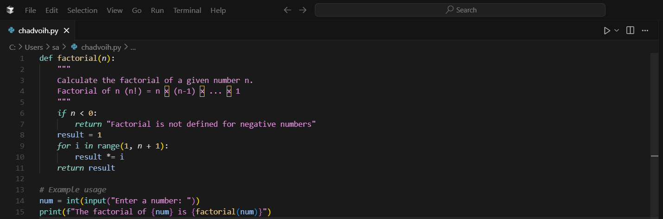

OUTPUT:
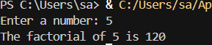
EXPLANATION:
What the code does:
Function Definition (factorial):
- Takes a number n as input
- Calculates the factorial of that number (n!)
- Factorial means: n × (n-1) × (n-2) × ... × 1
- For example: 5! = 5 × 4 × 3 × 2 × 1 = 120
How it works:
- Input validation: Checks if the input is negative (factorials aren't defined for negative numbers)
- Calculation: Uses a loop to multiply all numbers from 1 to n together
- Returns: The factorial result or an error message for negative numbers
Example usage:
- The program asks the user to input a number
- It then calculates and displays the factorial of that number
Example outputs:
- Input: 5 → Output: "The factorial of 5 is 120"
- Input: 3 → Output: "The factorial of 3 is 6"
- Input: -1 → Output: "The factorial of -1 is Factorial is not defined for negative numbers"
This is a basic mathematical utility program that demonstrates loops, conditional statements, and function definitions in Python.
--------------------------------------------------------------------------------------------------------------

TASK 5:
● Student need to write code to calculate sum of odd number and even numbers in the list
CODE :
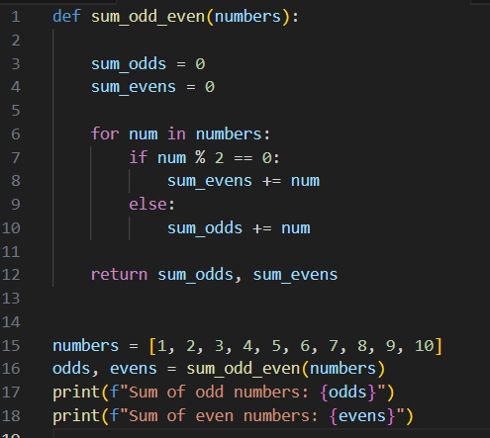
Output:
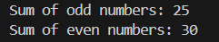

Explanation:
The program defines a function sum_odd_even(numbers) that loops through each element of a list. It checks whether each number is even or odd using the modulo operator %. Odd numbers are added to sum_odds and even numbers to sum_evens. Finally, it returns both sums. Example: For [1,2,3,4,5], odd sum = 9, even sum = 6.

